Problem 1 (a to d 4pts each, e 16pts)

Does a zinc supplement taken at the onset of cold symptoms reduce the time one has a cold? Five volunteers (Dan, Hal, Joe, Kay, and Zoe) agree to take part in an experiment. Three are assigned completely at random to receive the zinc supplement and the other two receive the placebo. The experiment is double-blind. The results are (times are duration of cold in hours):

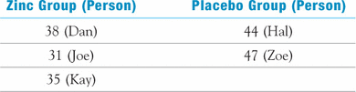

(a)There are 10 possible ways the five subjects can be assigned to the two groups, with the zinc group having size 3 and the placebo group size 2. List these.

(b)For each, determine the difference in mean length of cold (mean for the placebo group minus mean for the zinc group). Combine any duplicates and make a table of the possible mean differences and the corresponding probability of each under the null hypothesis of no treatment effect. (Each of the 10 possible assignments of subjects to treatments has probability 1/10 under the null hypothesis.) This is the permutation distribution.

(c)Compute the *P*-value of the data. Assume the alternative hypothesis is that the mean duration of a cold is less for zinc.

(d)In this example, is it possible to demonstrate significance at the 5% level using the permutation test? Explain.

(e)Assume that cold duration is Normally distributed for both zinc and the placebo. Use the two-sample *t* procedure to test the hypotheses. (Use SAS and byhand for two sample t-test).